Acceptance tests
Acme-Raffle 2.0
Development team
Identifier | FINALFANTASY
Members | SANCHEZ REYES, ADRIAN  BOZADA MARQUEZ, JESUS ENRIQUE  GIRALDO RUIZ, JOSE  LOPEZ MUÑOZ, JUAN CARLOS  DANS CABALLERO, MARIA REMEDIOS  CAMPOS ROMERO, MIGUEL
Testing team
Identifier | ReiCarMacLuqQuiMin
Members | CARRASCOSA OLIVA, SERGIO  REINA LOPEZ, PABLO  LUQUE MENDOZA, JOSÉ MANUEL  VALERA QUIANO, SILVIA  MINGUEZ LEÓN, ANTONIO JESÚS  MACÍAS LÓPEZ, PABLO
Indexing data
Test designers | GIRALDO RUIZ, JOSÉ  DANS CABALLERO, MARÍA REMEDIOS
Testers | MINGUEZ LEÓN, ANTONIO JESÚS  MACÍAS LÓPEZ, PABLO
Notes

Table of contents
LEVEL C 3
Use case 001 Pay his or her bills by attaching a valid credit card to them 3
Use case 002 Start a process that computes the bills that every manager must pay. The input to the process must be the month and the year for which the bills must be generated. Note that the system must prevent the administrator from running the process on a month or a year for which it’s already been run. By default, the system must pro-pose the current month and year as input to the process 4
Use case 003 Show a listing of default debtors. A manager is considered a default debtor when he or she has at least three unpaid bills 5
Use case 004 Ban default debtors, which prevents them from logging in to the system and users from participating in their raffles 6
Use case 005 Display a dashboard with the following information 7
LEVEL B 8
Use case 006 Browse his or her curriculum 8
Use case 007 Manage his or her curriculum, which includes displaying and editing it 9
LEVEL A 10
Use case 008 See the corresponding Hall of Fame, which consists of a listing with the winners and the users who have entered at least 75% the average number of codes entered by the users of the system 10
Additional tests 11

LEVEL C

Use case 001 Pay his or her bills by attaching a valid credit card to them

Description
A manager must be able to access pay his or her bills by attaching a valid credit card to them
Access
Any authenticated actor can access this use case. Please, use the following credentials:
User: manager1
Password: manager1
Tests
Test 1
Description | Pay his or her bills by attaching a valid credit card to them
Expected | Once in the master page, the 'List of Bills - Pay Bill?'. It must work in both languages.
Outcome | Lista de facturas:  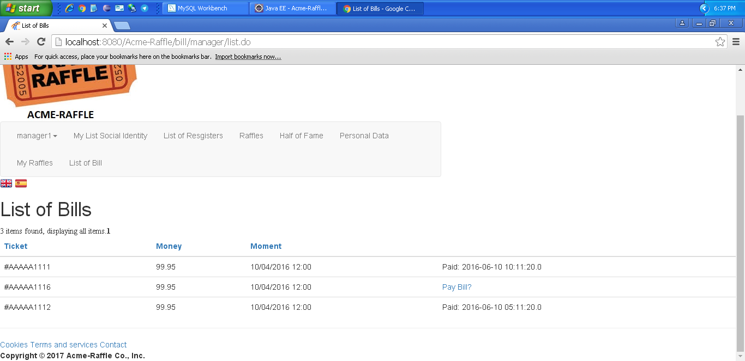  Después de pagar la factura:  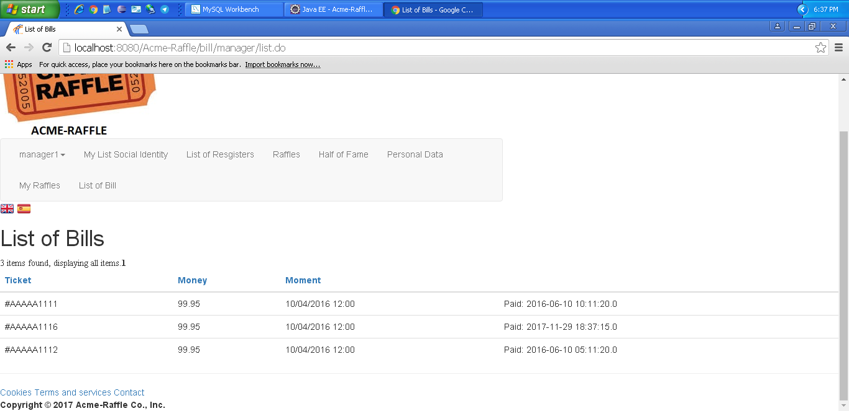
Notes

Use case 002 Start a process that computes the bills that every manager must pay. The input to the process must be the month and the year for which the bills must be generated. Note that the system must prevent the administrator from running the process on a month or a year for which it’s already been run. By default, the system must pro-pose the current month and year as input to the process

Description
An admin must be able to access start a process that computes the bills that every manager must pay. The input to the process must be the month and the year for which the bills must be generated. Note that the system must prevent the administrator from running the process on a month or a year for which it’s already been run. By default, the system must pro-pose the current month and year as input to the process
Access
Any authenticated actor can access this use case. Please, use the following credentials:
User: admin
Password: admin
Tests
Test 1
Description | Start a process that computes the bills that every manager must pay. The input to the process must be the month and the year for which the bills must be generated. Note that the system must prevent the administrator from running the process on a month or a year for which it’s already been run. By default, the system must pro-pose the current month and year as input to the process
Expected | Once in the master page, the 'Generate Bills' tab will lead to the lgenerate view. It must work in both languages.
Outcome | Funciona correctamente:  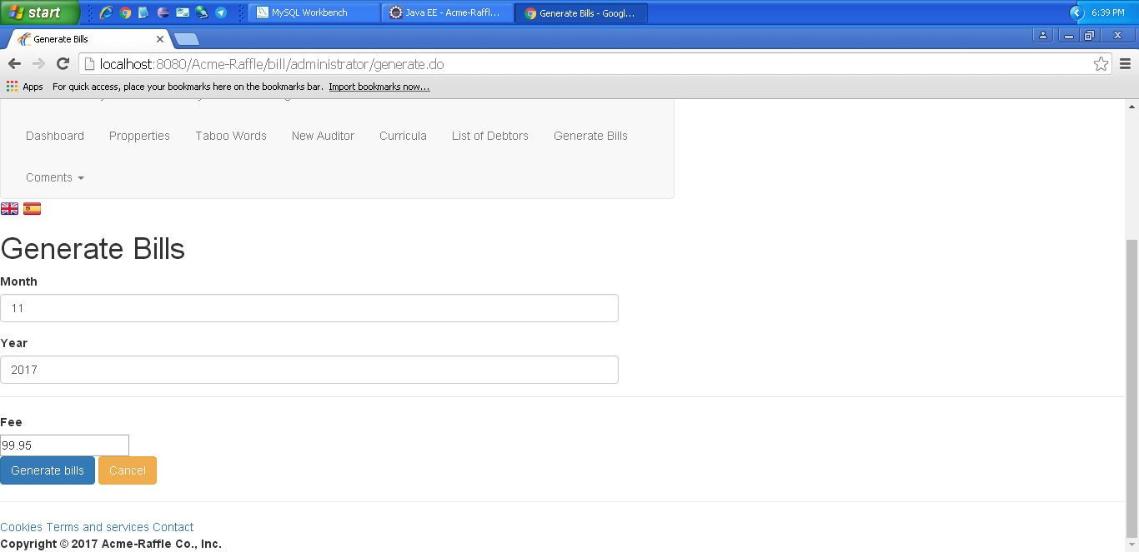
Notes

Test 2
Description | Start a process that computes the bills that every manager must pay. The input to the process must be the month and the year for which the bills must be generated. Note that the system must prevent the administrator from running the process on a month or a year for which it’s already been run. By default, the system must pro-pose the current month and year as input to the process
Expected | Ponemos una cantidad negativa en el fee. Nos muestra un mensaje de error.
Outcome | Error. Nos deja generar las facturas tranquilamente.
Notes

Use case 003 Show a listing of default debtors. A manager is considered a default debtor when he or she has at least three unpaid bills

Description
An admin must be able to access show a listing of default debtors. A manager is considered a default debtor when he or she has at least three unpaid bills
Access
Any authenticated actor can access this use case. Please, use the following credentials:
User: admin
Password: admin
Tests
Test 1
Description | Show a listing of default debtors. A manager is considered a default debtor when he or she has at least three unpaid bills
Expected | Once in the master page, the 'List of Debtors ' tab will lead to the list view. It must work in both languages.
Outcome | Funciona correctamente. Lista de deudores:  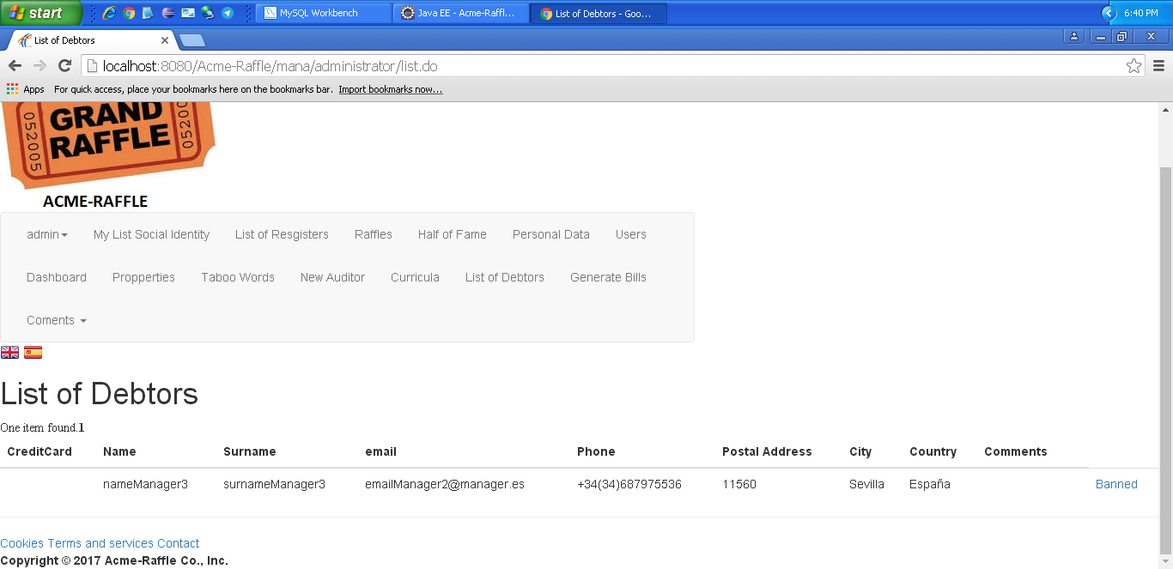
Notes

Use case 004 Ban default debtors, which prevents them from logging in to the system and users from participating in their raffles

Description
An admin must be able to access ban default debtors, which prevents them from logging in to the system and users from participating in their raffles
Access
Any authenticated actor can access this use case. Please, use the following credentials:
User: admin
Password: admin
Tests
Test 1
Description | Ban default debtors, which prevents them from logging in to the system and users from participating in their raffles
Expected | Once in the master page, the 'List of Debtors - Banned'. It must work in both languages.
Outcome | Funciona correctamente. Antes de banear:  Después:  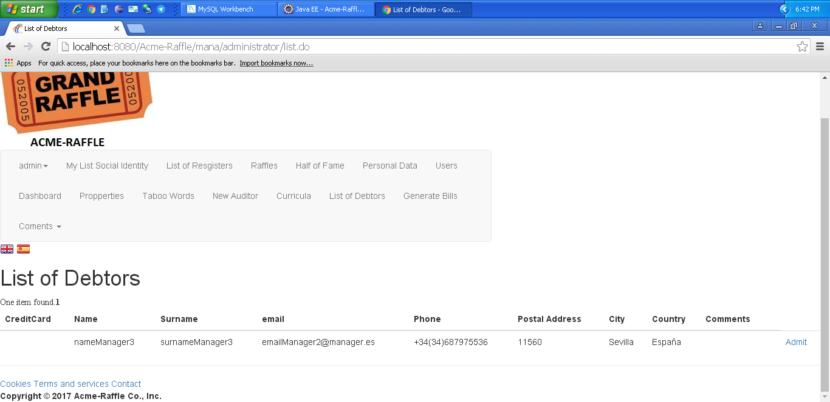  Intentamos iniciar sesión con ese usuario:  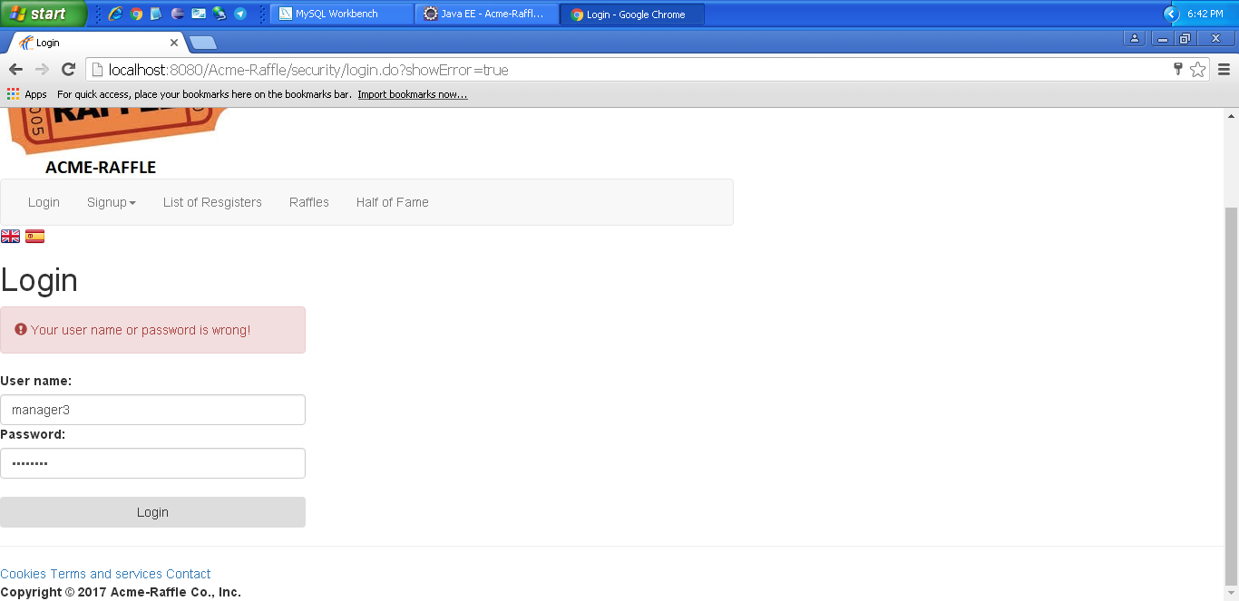
Notes

Use case 005 Display a dashboard with the following information

Description
An admin must be able to access display a dashboard with the following information
Access
Any authenticated actor can access this use case. Please, use the following credentials:
User: admin
Password: admin

Tests
Test 1
Description | Display a dashboard with the following information
Expected | Once logged in, 'Dashboard' It must work in both languages.
Outcome | Se muestra el dashboard correctamente:  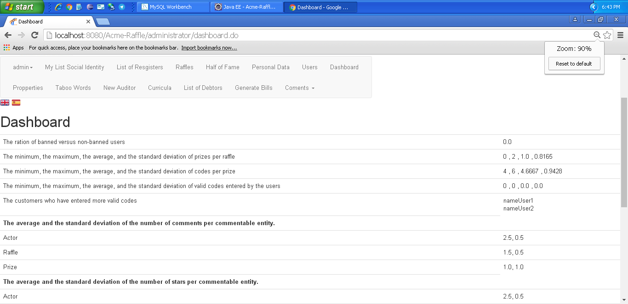
Notes

LEVEL B

Use case 006 Browse his or her curriculum

Description
An actor who can display the profile of an auditor must be able to:
Access
Any authenticated actor can access this use case. Please, use the following credentials:
User: user1
Password: user1
User: manager1
Password: manager1
User: auditor1
Password: auditor1
User: admin
Password: admin
Tests
Test 1
Description | Browse his or her curriculum
Expected | Podemos listar el curriculum de un auditor.
Outcome | Ok. Se lista correctamente el curriculum:  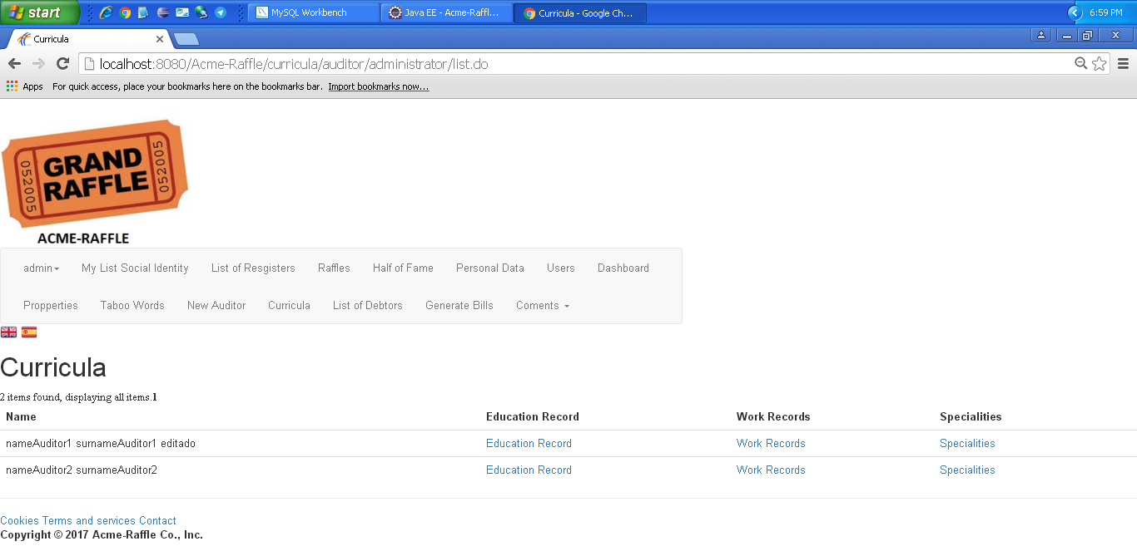
Notes

Use case 007 Manage his or her curriculum, which includes displaying and editing it

Description
An auditor must be able to manage his or her curriculum, which includes displaying and editing it
Access
Any authenticated actor can access this use case. Please, use the following credentials:
User: auditor1
Password: auditor1
Tests
Test 1
Description | Edit curriculum
Expected | Once logged in, 'Curricula - edit' tab will lead to the edit view. It must work in both languages.
Outcome | Formulario para editar curricula:  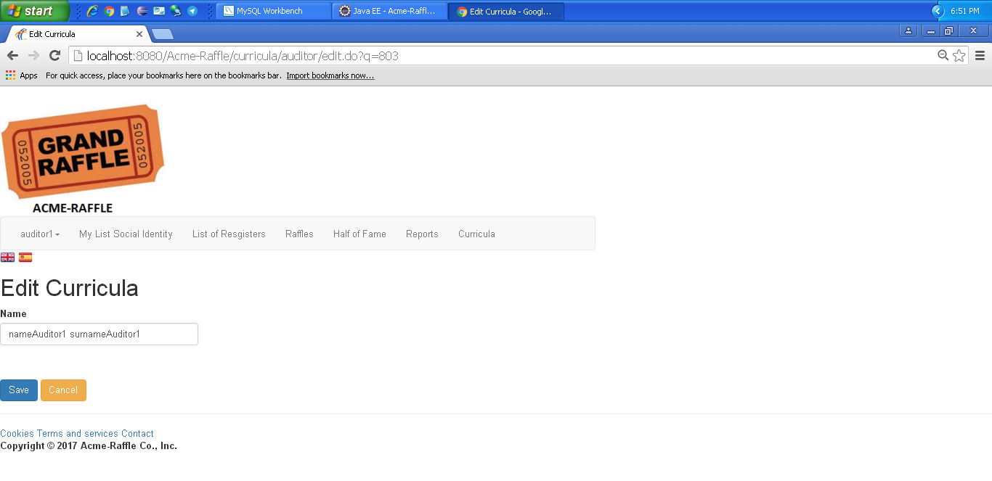  Después de editarlo:  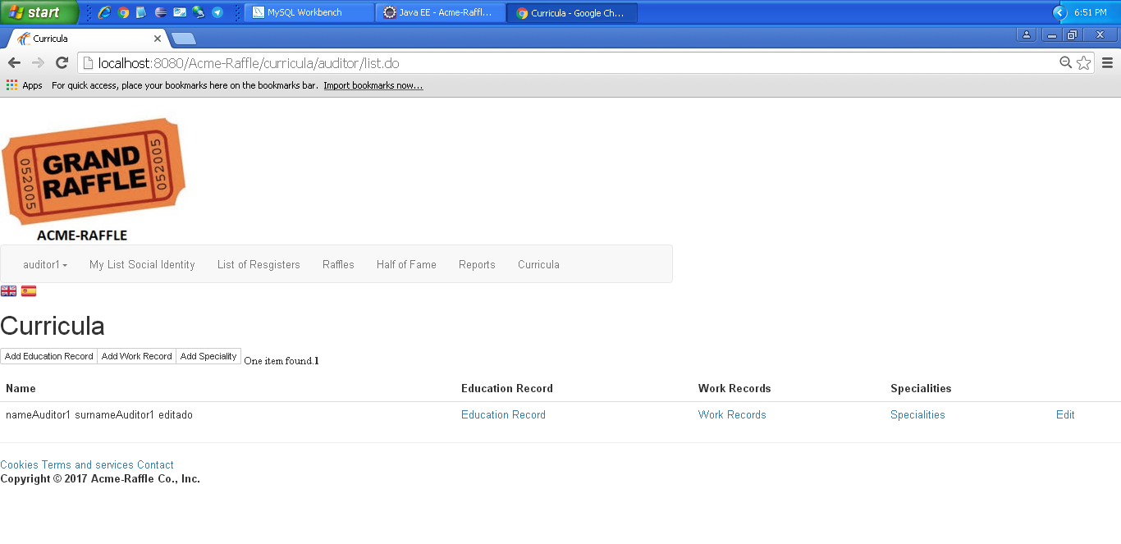
Notes
Test 2
Description | Edit curriculum
Expected | Intentamos editar un curriculum dejándolo en blanco. Nos debe mostrar un mensaje de error.
Outcome | Error. Nos permite dejar el curriculum en blanco.
Notes

Test 3
Description | Edit education record
Expected | Editamos el campo education record correctamente.
Outcome | Formulario para editar education record:  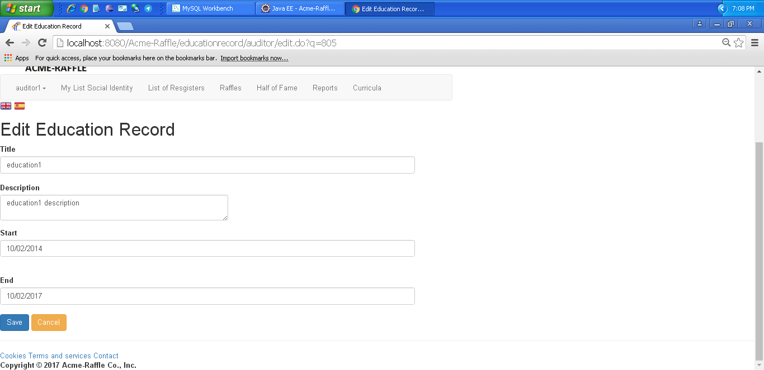  Después de editarlo:  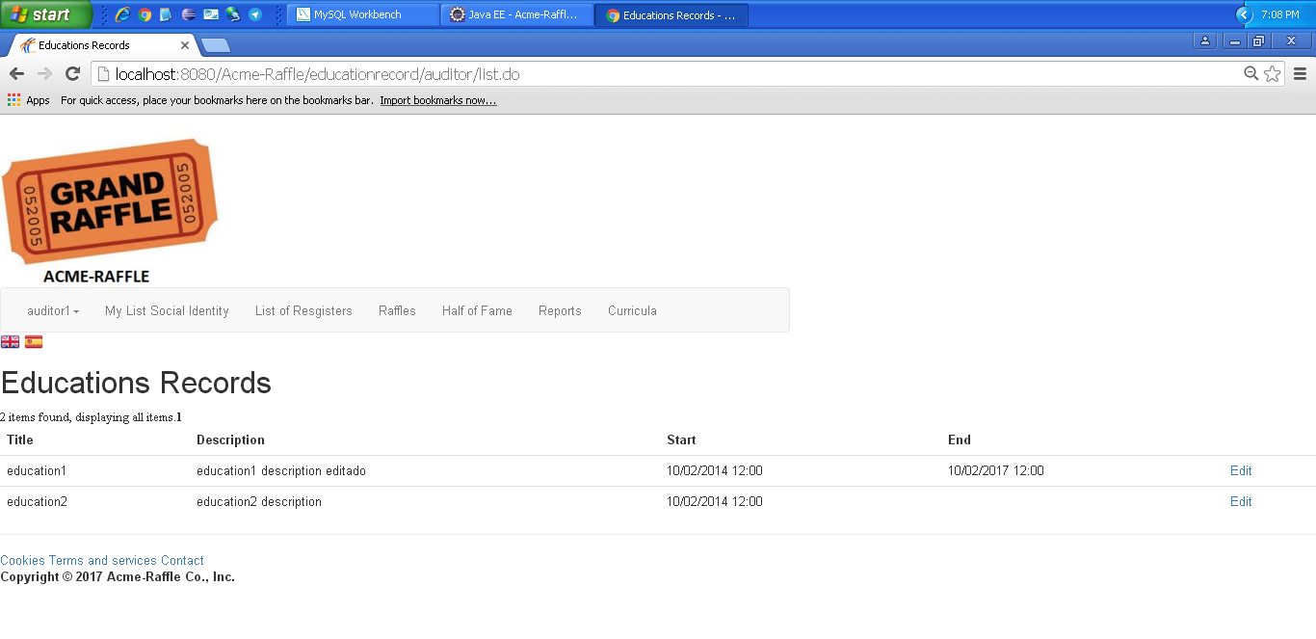
Notes

Test 4
Description | Edit education record
Expected | Editamos el campo education record dejando el título en blanco. Nos salta un error y no nos deja editar.
Outcome | Error. Nos permite dejar el título en blanco.
Notes

Test 5
Description | Edit education record
Expected | Editamos el campo education record poniendo el campo start después del campo end. Nos salta un error y no nos deja editar.
Outcome | Error. Nos permite editar el education record.
Notes

Test 6
Description | Edit education record
Expected | Editamos el campo education record poniendo el campo start en futuro. Nos salta un error y no nos deja editar.
Outcome | Error. Nos permite editar el education record.
Notes

LEVEL A

Use case 008 See the corresponding Hall of Fame, which consists of a listing with the winners and the users who have entered at least 75% the average number of codes entered by the users of the system

Description
An actor must be able to access See the corresponding Hall of Fame, which consists of a listing with the winners and the users who have entered at least 75% the average number of codes entered by the users of the system

Access
Any authenticated actor can access this use case. Please, use the following credentials:
User: user1
Password: user1
User: manager1
Password: manager1
User: auditor1
Password: auditor1
User: admin
Password: admin

Tests
Test 1
Description | See the corresponding Hall of Fame, which consists of a listing with the winners and the users who have entered at least 75% the average number of codes entered by the users of the system
Expected | Once logged in, 'Half of Fame' It must work in both languages.
Outcome | Funciona correctamente.
Notes

